Facebook’s Prophet
- One of the drawbacks of the SARIMAX Model is that one cannot have multiple seasonality and can only select one value.
- To overcome this disability, we're studying an open-source tool/library called prophet which is developed by Facebook

The following are the features of Facebook's Prophet:
- Provides intuitive parameters which can be easily tuned
- It is robust to missing data and shifts in the trend, and typically handles outliers well.
- It can account for multiple seasonalities. This is possible because, under the hood, the math of seasonalities is based on Fourier transforms, which help incorporate this.
- The Prophet uses a decomposable time series model with three main model components
- They are combined in the following equation:
y(t)= g(t) + s(t) + h(t) + εt
- g(t): piecewise linear or logistic growth curve for modeling non-periodic changes in time series (trend)
- s(t): periodic changes (e.g. weekly/yearly seasonality)
- h(t): effects of holidays (user provided) with irregular schedules
- εt: error term accounts for any unusual changes not accommodated by the model.

- For using Prophet, the data set should contain only two columns with column names as ‘ds’ and ‘y’
- ‘ds’ should always be in ‘date-time’ format. And ‘y’ represents a feature that you want to forecast.

- To install prophet to your environment, you can use the following environments:

!pip install pystan~=2.14
!pip install fbprophet

→ from fbprophet import Prophet
m = Prophet()
m.fit(df[['ds', 'y']][:-39]) #here we are leaving last 39 observations because we will predict it in 'future'
future = m.make_future_dataframe(periods=39,freq="D")
forecast = m.predict(future)
fig = m.plot(forecast)
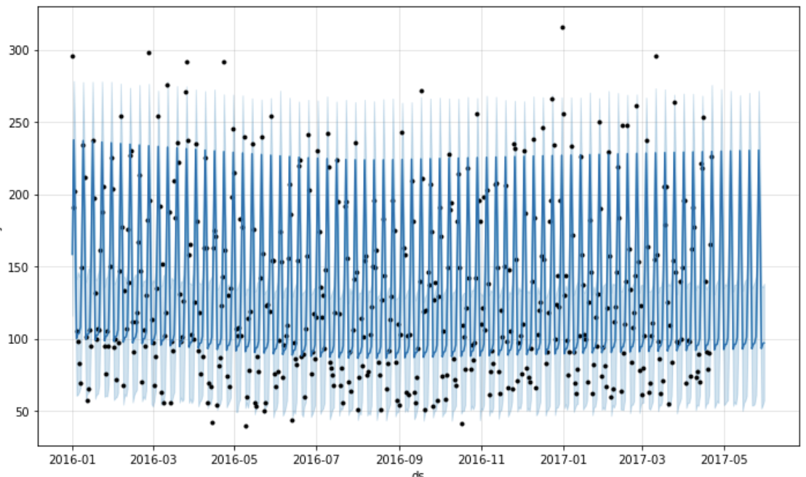

- In the plot, black dots are actual visits, deep blue lines are the predicted visits and light blue lines is the 95% confidence interval around the prediction.
- You can see that the lines are flat and the model is not able to capture the seasonality properly so it is not a good fit.
- Here light blue lines are 95% confidence intervals around the predictions.
- Here we also didn't do anything explicitly for NaNvalues it was handled by the prophet.
- We can use ‘add_regressor’ for adding features to the prophet model.
  - There is another interesting parameter here: ‘changepoint_prior_scale’
- If the trend changes are being overfit (too much flexibility) or underfit (very less flexibility)
- We can adjust the strength of sparse prior using this parameter.
- Default value: 0.05
- Increasing this will make the trend more flexible.

→ model2=Prophet(interval_width=0.95, yearly_seasonality=True, weekly_seasonality=True,changepoint_prior_scale=4)

model2.add_regressor('holiday') #adding holidays data in the model3
model2.fit(df[:-39])
forecast2 = model2.predict(df)
fig = model2.plot(forecast2)
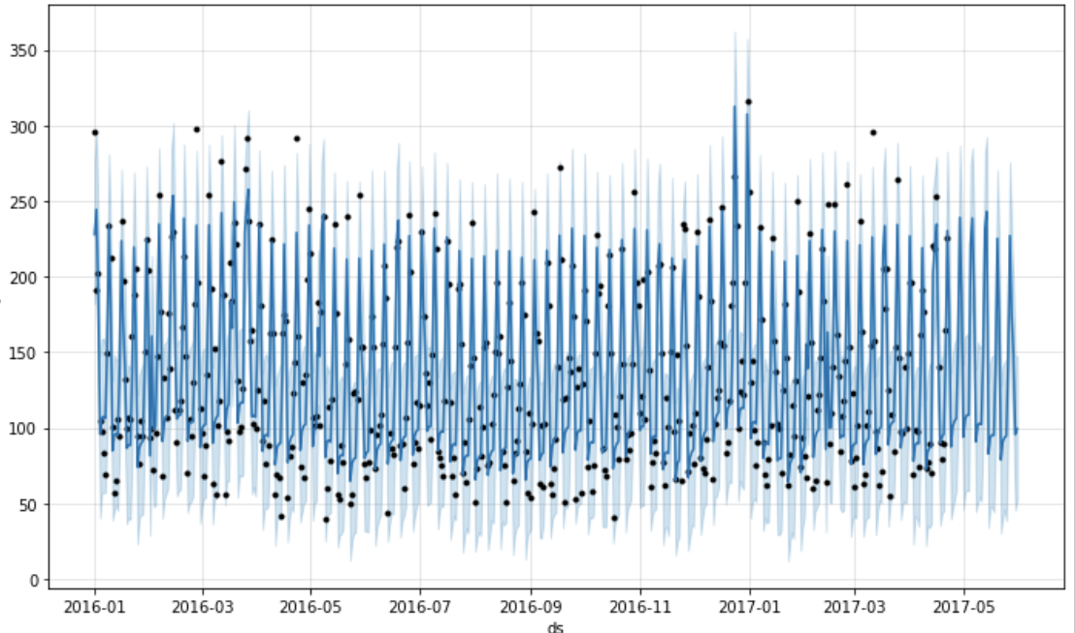

Changing Trends
- Prophet automatically detects the changepoints and will allow the trend to adapt appropriately.
- Prophet detects changepoints by first specifying a large number of potential changepoints at which the rate is allowed to change.

→ from fbprophet.plot import add_changepoints_to_plot
fig = m.plot(forecast2)
a = add_changepoints_to_plot(fig.gca(), m, forecast2)
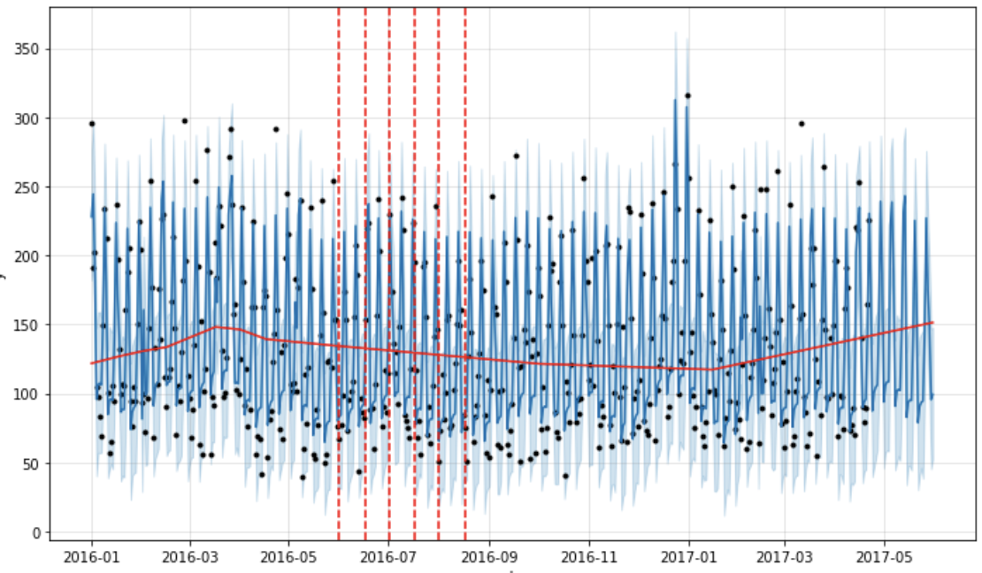

- The vertical lines in this figure indicate where the potential change-points were placed.
- Facebook prophet provides automated methods to forecast.
- The model has easily interpretable parameters that can be changed by the analyst to impose assumptions on the forecast.

Benefits of Prophet
- The prophet is a simple library and is great for beginners.
- It works best with time series that have strong seasonal effects.
- Prophet is robust to missing data and shifts in the trend, and typically handles outliers well.
- We can add multiple regressors or exogenous variables.
- It forms a very good baseline model because almost no feature engineering is required.
- Interpretability is one of the key advantages of the Prophet.
- If your time series follows some business cycles, you can obtain very decent performance quickly.
- It can also be helpful while detecting change points.

